Mohammad Widyarta

Universitas Indonesia

**Silaban, Friedrich (1912–1984)**

Friedrich Silaban was an Indonesian architect who aimed to create a modern architecture that was applicable in Indonesia’s tropical climate and social condition. He was born in Bonandolok and died in Bogor. Silaban studied at the Royal Willhelmina School in Jakarta, which was then known as Batavia. He started his career during the colonial period in the Public Work Services. After Indonesia gained independence from the Netherlands in 1949, Silaban worked for Indonesia’s Ministry of Public Works. Nevertheless, he ran his own architecture office in Bogor. At one time during the 1950s, as a practising architect, he partnered with Han Groenewegen, a Dutch architect who had become an Indonesian citizen. This partnership resulted in a building which is considered as one of Silaban’s most important works, the head office of Bank Indonesia on Thamrin Street, Jakarta (1954).

Silaban achieved his career peak during 1950s and 1960s. At that time, Indonesia was led by President Sukarno, who preferred modernist architecture in order to represent his new nation in a post-independence context. Some of Silaban’s most important works, such as the aforementioned Bank Indonesia’s head office and Istiqlal Mosque (1954) were commissioned after he had won design competitions initiated by the Indonesian government. The government also commissioned Silaban for other works in Jakarta, such as Gedung Pola, commissioned in 1961, and the Hotel Banteng in 1965. Finished and slightly modified by another architect after the fall of President Sukarno, it is now known as Hotel Borobudur. An emphasis on the roof and a tendency to render the walls as less important are evident in Silaban’s major works, including his own house in Bogor (1959).

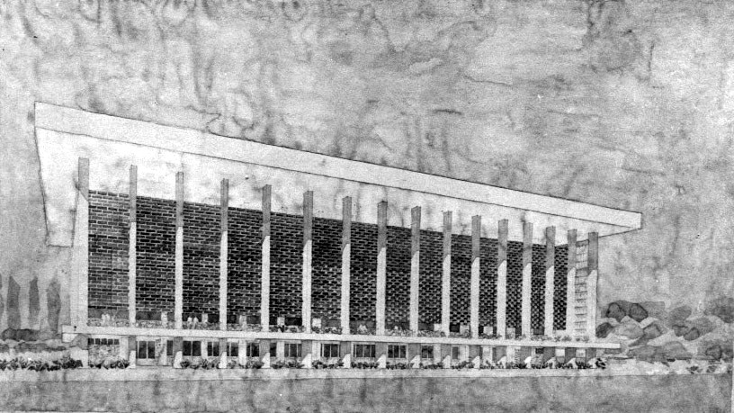

Perspective of Gedung Pola (1961), Jakarta (Source: F. Silaban archive; courtesy of mAAN Indonesia, 2008).

NOTE TO EDITOR: this photo may require copyrights permission from modern Asian Architecture Network (mAAN) Indonesia. Please contact Mr. Setiadi Sopandi of mAAN Indonesia at *cungss@gmail.com* for further information.

**List of Works**

1954 Bank Indonesia Head Office, Jakarta (with Han Groenewegen).

1954 Istiqlal Mosque, Jakarta.

1959 Silaban’s House, Bogor.

1961 Gedung Pola, Jakarta.

1965 Hotel Banteng, Jakarta.

**References and Further Reading**

Adiyanto, J., *et. al*. (2008) *RumahSilaban/Silaban House*, Jakarta: mAAN Indonesia Publishing.

Sopandi, S. (2009) “Indonesian Architectural Culture during Guided Democracy (1959 – 1965): Sukarno and the Works of Friedrich Silaban,” in *Dynamics of the Cold War*, Tuong Vu and W. Wongsurawat, eds., New York: Palgrave Macmillan.

Interview with Friedrich Silaban’s son, Panogu, in Depok, February 22, 2012.